##### *ASC MonoPos Horizontal*

##### Semester One Examination, 2014

##### Question/Answer Booklet

CHEMISTRY

**Stage 3 ANSWERS**

**Section One: Multiple-choice 25% (25 Marks)**

This section has **25** questions. Answer **all** questions on the Multiple-choice Answer Sheet provided. Use only blue or black pen to shade the boxes. If you make a mistake, place a cross through that square. Do not erase or use correction fluid. Marks will not be deducted for incorrect answers. No marks will be given if more than one answer is given for any question.

Suggested working time: 50 minutes.

___________________________________________________________________________

1. Which of the following best describes the molecular shape and molecular polarity of a chloroform molecule whose formula is CHC3?

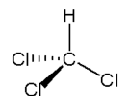

A. pyramidal, non-polar

B. tetrahedral, non-polar

C. pyramidal, polar

**D. tetrahedral, polar**

2. An element X has the following five successive ionisation energies (in kJ mol−1)

680 1600 8000 11600 14500

What would be the formula of the compound formed when “X” reacts with oxygen?

**A. XO** **X has two valence electrons**

B. X2O **∴ X2+**

C. X2O3 **∴ oxide is XO**

D. XO2

3. Which of the following physical properties **decrease** with increasing atomic number for both the alkali metals and the halogens?

I Atomic radius **🗙 (increases for both)**

II Ionisation energy **✓**

III Melting point **🗙 (decreases for alkali metals, increases for halogens)**

**A. II only**

B. I and II only

C. I, II and III

D. I and III only

4. Which one of the following solids contains ionic and covalent bonds?

A. H2O

B. MgO

**C. NH4Br**

D. Ne

5. A crystal of iodine, I2, produces a purple vapour when gently heated. Which pair of statements correctly describes this process?

*Type of bond broken Formula of purple species*

A. covalent I

B. covalent I2

**C. dispersion forces I2**

D. dipole-dipole I2

6. Which of the following statements is correct?

A. Covalent network solids have strong van der Waal’s forces between atoms.

**B. Metal solids exhibit non-directional inter-particle bonding.**

C. Ionic solids conduct electricity very well in the aqueous and solid states.

D. Covalent molecular solids tend to decompose before melting.

7. Which of the following has a different number of electrons from the other three?

**A. O3****3 x 8 = 24**

B. Sc3+ **21 – 3 = 18**

C. C2H6 **6 + 6 + (6 x 1) = 18**

D. CH3F **6 + (3 x 1) + 9 = 18**

8. Hydrogen bromide has a low melting point because it consists of

A. oppositely charged ions bonded by weak electrostatic attractive forces

B. positive ions electrostatically attracted to delocalised electrons

C. non-metal atoms covalently linked in a lattice

**D. molecules linked by weak intermolecular attractive forces.**

9. Tungsten, one of the transition metals, has a very high melting point but not as high as carbon in the form of diamond. This is best explained by:

A. Diamond has greater dispersion forces between its atoms than tungsten.

**B. The covalent bonding present between diamond’s carbon atoms is stronger**

**than the metallic bonding in tungsten.**

C. Tungsten has fewer valence electrons than carbon, so the less delocalised

electrons create the lower melting point.

D. Diamond’s molecules are polar, and the dipole-dipole attraction in diamond is

stronger than the metallic bonding in tungsten.

10. Consider the following potential energy diagram for a chemical reaction.

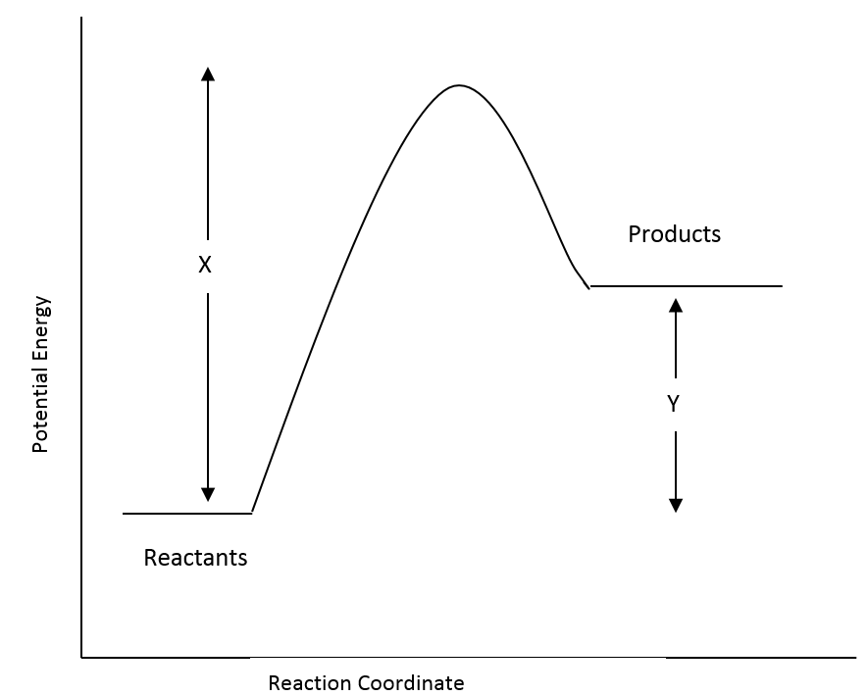

Which one of the following statements about this reaction is **incorrect**?

**A. The reaction mixture will become hotter as the reaction proceeds.**

B. The activation energy for the reverse reaction is (X–Y).

C. ΔH for the reverse reaction is −Y.

D. The forward reaction rate is likely to be slower than the reverse reaction rate.

11. HC, HBr and HI have boiling points of −85oC, −67oC and −35oC, respectively. The

best explanation for this trend in boiling points is:

A. The strength of hydrogen bonds increases as they progress down a column of the

Periodic Table.

B. The molecules HC, HBr and HI show increasing polarity.

**C. The strength of dispersion forces increases as the number of electrons in a**

**molecule increases.**

D. The strength of hydrogen bonds decreases as the number of electrons in a

molecule increases.

12. In the process for the preparation of methane:

C(s) + 2 H2(g) ⇄ CH4(g) ∆H = −75 kJ mol−1

If the equilibrium system temperature is increased, what effect will this have on the

equilibrium constant, K, and the yield of CH4?

*Equilibrium constant, K Yield of CH4*

A. decrease increase

**B. decrease decrease**

C. increase increase

D. increase decrease

13. The equilibrium constant, K, for the reaction,

2 H2(g) + O2(g) ⇄ 2 H2O(g) is equal to 2 x 1081  at 25oC.

This value suggests that:

A. this reaction favours the forward reaction slightly more than the reverse reaction.

B. this reaction favours the reverse reaction slightly more than the forward reaction.

**C. this reaction virtually goes to completion with little reversal.**

D. this reaction virtually does not proceed forward and largely favours the reactants.

**Questions 14 and 15 refer to the following four substances.**

|  |  |  |
| --- | --- | --- |
|  | *Name* | *Structure* |
| I | hydroxylamine |  |
| II | methanol |  |
| III | methoxymethane |  |
| IV | ethyl ethanoate |  |

14. In which of the above substances would you expect hydrogen bonding to be present between their molecules?

A. All of them

B. I, II and III

**C. I and II**

D. II and IV

15. Which is the only one of the above molecules that has a trigonal planar arrangement of

atoms around one of the atoms in the molecule?

A. hydroxylamine

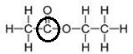

B. methanol

C. methoxymethane

**D. ethyl ethanoate**

16. A row of test tubes containing iron (III) ions, thiocyanate ions (SCN−) and the complex

ion iron (III) thiocyanate (Fe(SCN)2+) are set up and allowed to come to equilibrium.

The equilibrium equation is:

Fe3+(aq) + SCN−(aq) ⇄ Fe(SCN)2+(aq) + HEAT

*yellow colourless red*

The test tubes appear orange due to the relative colours of the three ions.

Which of the following changes would **not** be expected to occur in association with the

change described in the table below? (Note: AgSCN is insoluble)

|  |  |  |
| --- | --- | --- |
|  | *Imposed change* | *Colour at the new equilibrium* |
| A. | Some NaSCN(s) is added and it dissolves into its ions. | Solution becomes more red. |
| **B.** | **Some AgNO3(s) is added, it dissolves and a white solid AgSCN forms.** | **Solution becomes more red.** |
| C. | Some NaOH(s) is added, it dissolves and a brown solid forms. | Solution becomes more yellow. |
| D. | A test tube of the mixture is heated to near boiling point. | Solution becomes more yellow. |

**The next two questions, 17 and 18, refer to the following information:**

Methanol is made commercially by pumping a mixture of carbon monoxide and hydrogen through a reaction chamber containing ZnO and Cr2O3. The equilibrium equation for the reaction is:

CO(g) + 2 H2(g) ⇄ CH3OH(g) ΔH = −91 kJ mol−1

17. Which of the following conditions would favour the highest yield of the product methanol?

**A. low temperature and high pressure.**

B. low temperature and low pressure.

C. high temperature and low pressure.

D. high temperature and high pressure.

18. What is the likely function of the ZnO and Cr2O3?

A. These conduct away the heat and help favour the forward reaction.

B. These absorb the alcohol formed so it can be evaporated off later.

C. These transition metal oxides lower the ΔH of the reaction making it go faster.

**D. These may be catalysts that enable equilibrium to be achieved faster.**

19. Consider the reaction between 1.00 g of lithium carbonate powder and 100.0 mL of 0.200 mol L–1 ethanoic acid. Which of the following changes would result in an increase in the initial rate of reaction?

A. Change the lithium carbonate powder to a single lump.

**B. Change from 0.200 mol L–1 ethanoic acid to 0.200 mol L–1 hydrochloric acid.**

C. Change from 100 mL of ethanoic acid to 200 mL of ethanoic acid.

D. Increase the pressure.

20. The substances pentane, propan-1-ol and propanone have the following structural

formulae

|  |  |
| --- | --- |
| pentane |  |
| propan-1-ol |  |
| propanone |  |

Which of the following lists pentane, propan-1-ol and propanone in order of decreasing solubility in water?

A. pentane > propanone > propan-1-ol

B. propanone > pentane > propan-1-ol

C. propan-1-ol > pentane > propanone

**D. propan-1-ol > propanone > pentane**

21. A catalyst

A. lowers the activation energy of a given reaction.

B. speeds up a reaction but does not take part in the reaction.

**C. creates a new pathway for the reaction.**

D. lowers the ΔH of the reaction making it easier to achieve.

22. Which is the correct equilibrium constant expression for the following equation?



A. [Fe3O4] [H2]

[Fe] [H2O]

B. [Fe3O4] [H2]4

[Fe]3 [H2O]

C. [Fe3O4] + 4[H2]

3 [Fe] + 4[H2O]

**D. [H2]4**

**[H2O]4**

23. Consider the equilibrium established in the formation of phosphorous pentoxide:

P4(s) + O2(g) ⇄ P4O10(s) ΔH = –ve

Which of the following changes would lead to a new equilibrium with a change in the

concentration of O2?

A. Addition of P4(s) **K = 1 / [O2]**

B. Decreasing the surface area of P4O10(s) **since K is constant,**

C. Addition of O2(g) **[O2] is constant, unless ΔT**

**D. Decreasing the temperature**

24. Which of the following correctly identifies the trends in atomic radii, first ionisation energy and electronegativity as you go across period 3 from Na to C?

Atomic radii First Ionisation Energy Electronegativity

---------------------------------------------------------------------------------------------

**A. Decreases Increases Increases**

B. Increases Decreases Increases

C. Decreases Increases Decreases

D. Increases Decreases Decreases

**Question 25 refers to the following information:**

Lecithin is a phospholipid found in egg yolks. It is used in the making of mayonnaise because it helps to form a stable oil/water suspension (a homogeneous mixture). It is interesting in that it is a bipolar molecule with a negatively charged oxygen atom and positively charged nitrogen atom found within the overall neutral molecule. An organic chemist wishing to show its structure might show it as in the diagram below:

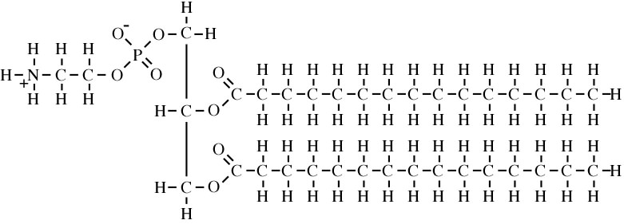

25. Given that oil is a non-polar molecule, what part(s) of the structure of lecithin enable it to form the stable oil/water suspension?

A. The bottom part of the molecule bonds with water droplets and the long

hydrocarbon to parts bond with oil.

**B. The charged parts of the molecule and the oxygen atoms throughout the**

**molecules bond with water and the carbon/hydrogen parts of it bond with**

**the oil.**

C. The positive nitrogen atom bonds with water and the negative oxygen atom bonds

with the oil.

D. The positive nitrogen atoms bond with oil and the negative oxygen atom bonds

with water.

**End of Section One**

**Section Two: Short Answer 35% (70 Marks)**

This section has **twelve (12)** questions. Answer **all** questions. Write your answers in the space provided.

Spare pages are included at the end of this booklet. They can be used for planning your responses and/or as additional space if required to continue an answer.

• Planning: If you use the spare pages for planning, indicate this clearly at the top of the page

• Continuing an answer: If you need to use the space to continue an answer, indicate in the original answer space where the answer is continued, i.e. give the page number. Fill in the number of the question(s) that you are continuing to answer at the top of the page.

Suggested working time: 60 minutes

___________________________________________________________________________

**Question 26 (10 marks)**

Consider the following system:

CO(g) + 2 H2(g) ⇄ CH3OH(g)

(a) At 25oC, K = 2.34 x 10−1. At 58oC, K = 4.56 x 10−2.

(4 marks)

Is the forward reaction exothermic or endothermic? **exothermic ✓**

Explain your answer:

**According to LCP, an increase in temperature causes a shift in equilibrium**

**in the direction of the endothermic reaction. ✓**

**As temperature increase, K decreases - this indicates 🡑[reactants] and**

**🡓[products]. ✓**

**∴ reverse reaction is endothermic and forward reaction is exothermic. ✓**

(b) Predict whether the following changes will increase, decrease or have no effect on both the forward rate and the equilibrium yield. (6 marks)

|  |  |  |
| --- | --- | --- |
| *Change* | *Effect on rate* | *Effect on yield* |
| Increasing the pressure of the system | **increase** | **increase** |
| Adding a catalyst | **increase** | **no effect** |
| Decreasing the temperature | **decrease** | **increase\*\*** |

**\*\* decrease if given as endothermic in part (a)**

**✓ each**

**Question 27 (8 marks)**

Phenolphthalein is a diprotic acid molecule (H2PhTh ) and has two different equilibrium situations which are sensitive to concentrations of OH–(aq). In the pH range less than or equal to 8.3 the molecular form is in high concentration. There is no evidence of the first ionisation step which would form H3O+(aq) and the pink coloured ion, HPhTh–(aq).

If the phenolphthalein molecule is written as H2PhTh, then the equilibrium equation for the first ionisation of phenolphthalein could be written as:

H2PhTh(aq) + H2O(l) ⇄ HPhTh–(aq) + H3O+(aq) ΔH = +ve

*colourless pink*

(a) From the information given above, is the K value for the equation as written going to be

high or low? Explain your answer. (2 marks)

**Phenolphthalein exists mostly in the molecular form,**

**so [H2PhTh] > [HPhTh–], [H3O+] ✓**

**Since K = [HPhTh–].[ H3O+] / [H2PhTh], K will be low. ✓**

(b) The following changes are imposed on a solution of phenolphthalein at equilibrium, which has a pale pink colour. Each change is made to a separate test tube and

equilibrium is re-established.

Complete the table below, indicating the effect on the concentration of HPhTh–(aq) and the value of K. Use terms ‘increase’, ‘decrease’ or ‘no change’.

Also describe what you would observe as equilibrium is re-established in the system.

(6 marks)

|  |  |  |  |
| --- | --- | --- | --- |
| *Imposed change* | *Effect on*  *[HPhTh–]* | *Effect on K* | *Observation* |
| HC(g) is bubbled  through the solution | **decrease** | **no change** | **change in colour from**  **pink to colourless** |
| The solution  is heated | **increase** | **increase** | **colour would**  **become ‘more pink’** |

**✓ each**

**Question 28 (10 marks)**

(a) **D** is removed from the system in the separation chamber at t1.

(i) Sketch graphs on the axes below showing how this affect the rates of the forward and reverse reactions. Continue your graph until equilibrium has been re-established at t2.

(3 marks)

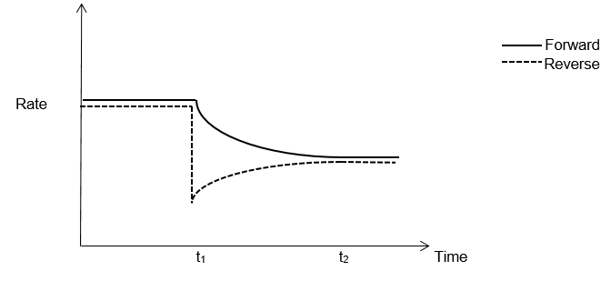

**✓ initial decrease in rev rate**

**& fwd initially unchanged**

**✓ shape of curves for rates between equilibria**

**✓ fwd rate = rev rate at t2**

**(and not well before t2)**

(ii) Explain the changes in rates of the forward and reverse reactions. (4 marks)

**With the removal of D(g), [D] decreases and rev rate decreases, due to**

**decreased frequency of collisions between products (i.e. D). ✓**

**Since fwd rate > rev rate, equilibrium shifts right and so:**

**- [reactants] decrease and the fwd rate decreases ✓**

**- [products] increase and rev rate increases ✓**

**The rates of forward and reverse become equal at t2, the new equilibrium. ✓**

(b) In practice the industrial process gives a poor yield of product **D**. As the equilibrium mixture of reaction 2 moves into the separation chamber, what changes would you make to the conditions to increase the yield of **D?**

*(No explanations are required)* (3 marks)

**Any three of the following:**

**Decrease volume (increased pressure) ✓**

**Decrease temperature ✓**

**Remove D (decrease concentration of product) ✓**

**Add B, C (increase concentration of reactant) ✓**

**Question 29 (4 marks)**

Write the equation for the reaction that occurs in each of the following procedures. If no reaction occurs, write ‘no reaction’. For full marks, chemical equations should refer only to those species consumed in the reaction and the new species produced. These species may be ions [for example Ag+(aq)], molecules [for example NH3(g), NH3(aq), CH3COOH(l)] or solids [for example BaSO4(s), Cu(s), Na2CO3(s)].

(a) Sodium hydrogencarbonate solution is mixed with hydrochloric acid solution. (2 marks)

Equation: **HCO3-(aq) + H3O+(aq) → 2 H2O(l) + CO2(g) ✓✓**

**or HCO3-(aq) + H+(aq) → H2O(l) + CO2(g)**

(b) Barium nitrate solution is mixed with sulfuric acid solution. (2 marks)

Equation: **Ba2+(aq) + SO42-(aq) → BaSO4(s) ✓✓**

**Question 30 (6 marks)**

Write observations for any reactions that occur in the following procedures (a) and (b).

In each case describe in full what you would observe, including any:

If no change is observed, then you should state this.

(a) Excess hydrochloric acid is added to copper (II) carbonate solid. (2 marks)

Observation: **A green solid dissolves completely forming a blue solution ✓**

**and a colourless, odourless gas evolves ✓**

(b) Excess iron (II) nitrate solution is mixed with sodium hydroxide solution. (2 marks)

Observation: **A pale green solution is added to a colourless solution**

**forming a pale green precipitate ✓**

**The solution remains pale green ✓**

(c) Write full observations for this reaction: (2 marks)

Cu(s) + 4 H+(aq) + 2 NO3−(aq) 🡒 Cu2+(aq) + 2 H2O(l) + 2 NO2(g)

Observation: **A salmon-pink solid dissolves forming a blue solution ✓**

**and a brown, pungent gas evolves ✓**

**Question 31 (5 marks)**

What is the pH of a mixture resulting from the addition of 500 mL of 0.10 mol L–1 NaOH and

750 mL of 0.050 mol L–1 HC?

**n(OH-) = n(NaOH) = c.V = 0.10 x 0.500 = 0.0500 mol ✓**

**n(H+) = n(HC) = c.V = 0.050 x 0.750 = 0.0375 mol ✓**

**H+(aq) + OH-(aq) → H2O(l) 1:1 ratio, ∴ H+ is limiting**

**n(OH-)consumed = n(H+) = 0.0375 mol**

**n(OH-)excess = 0.0500 – 0.0375 = 0.0125 mol ✓**

**Vtotal = 0.500 + 0.750 = 1.250 L**

**[OH-] = n/V = 0.0125/1.250 = 0.0100 mol L-1 ✓**

**pOH = -log [OH-] = 2**

**pH = 14 – pOH = 12 ✓**

***or [H+] = Kw/[OH-] = 1 x 10-12 mol L-1***

***pH = -log[H+] = 12***

**Question 32 (6 marks)**

For each species listed in the table below, draw the structural formula, representing all valence shell electron pairs either as **:** or as — **and** state or draw the shape of the molecule or ion.

|  |  |  |
| --- | --- | --- |
| *Molecule or ion* | *Structural formula* | *Shape* |
| H2CO |  | **trigonal planar** |
| SO32− | ***must have brackets & charge*** | **trigonal pyramidal**  **(or pyramidal)** |
| CS2 |  | **linear** |

**✓ each**

**-1 for missing non-bonding pairs**

**Question 33 (3 marks)**

The hydrogen phosphate ion, HPO42–(aq), is an unusual ion in that it can stabilise solutions by reacting with both small acid changes and small alkaline changes and help keep the pH at a near neutral position.

(a) What is the term used to describe this action of the hydrogen phosphate ion?

**buffer / buffering ✓**

(1 mark)

(b) Write equations showing how this ion responds to a small addition of: (2 marks)

(i) dilute HC(aq) **HPO42-(aq) + H3O+(aq) ⇄ H2PO4-(aq) + H2O(l) ✓**

(ii) dilute KOH(aq) **HPO42-(aq) + OH-(aq) ⇄ PO43-(aq) + H2O(l) ✓**

***Must have* ⇄ *for full marks***

**Question 34 (5 marks)**

The diagram below shows the energy distribution curve for a gaseous reaction at 25oC. The activation energy for the uncatalysed reaction is also indicated.

(a) Redraw the redraw the distribution curve for a temperature of 68oC. **✓**

(b) Show on the diagram the activation energy for the catalysed reaction. **✓**

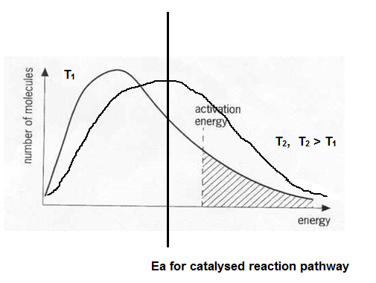

Explain, using the above diagram, how the rate of reaction is affected with increased temperature and addition of a catalyst.

**With increased temperature, there will be an increase in average kinetic energy of reactant molecules. This will result in an increase in:**

**- the frequency of collisions between reactants; and ✓**

**- the proportion of reactants with sufficient kinetic energy for bond breaking ✓**

**In the catalysed reaction pathway, the activation energy is lower, so there is a**

**greater proportion of reactants with sufficient kinetic energy for bond breaking ✓**

**There will be, therefore, an increase in the frequency of successful collisions**

**(i.e. collisions that result in the formation of products).**

**Question 35 (4 marks)**

(a) Explain these differences in the melting and boiling points in terms of their chemical

bonding.

**CC4 is a nonpolar molecule with only weak dispersion forces between molecules ✓**

**NaC is an ionic compound with much stronger ionic bonds between Na+ and C- ✓**

**∴ greater energy is required to disrupt bonding in NaC compared to CC4**

(2 marks)

(b) Explain the differences in their electrical conductivity in terms of their chemical bonding.

**Electrical conductivity requires the presence of mobile charged particles**

**CC4 is a neutral molecule, so is a non-conductor in any state ✓**

**In liquid NaC, the ions (Na+ and C-) are mobile and so it can transfer charge ✓**

(2 marks)

**Question 36 (3 marks)**

It was found that glue stuck on a desk was removed using ethanol but not hexane. By considering the structures of these molecules offer an explanation as to why the glue was soluble in one solvent but not the other.

**Ethanol is a polar solvent since the force of attraction between molecules is**

**hydrogen bonding. ✓**

**Hexane is a nonpolar solvent as there are only dispersion forces between**

**molecules. ✓**

**Since the glue is be removed by ethanol but not hexane we can infer that the glue contains polar molecules, interacting with the ethanol predominantly via dipole-dipole forces or hydrogen bonding. ✓**

**Question 37 (6 marks)**

|  |  |  |  |
| --- | --- | --- | --- |
| *Solution* | *Observation* | | *Equation* |
| *with red litmus* | *with blue litmus* |
| NaCH3COO | **blue** | **no change** | **CH3COO-(aq) + H2O(l) ⇄ CH3COOH(aq) + OH-(aq)** |
| NH4NO3 | **no change** | **red** | **NH4+(aq) + H2O(l) ⇄ NH3(aq) + H3O+(aq)** |

**✓ each**

***Must have* ⇄ *for full marks***

**End of Section Two**

**Section Three: Extended answer 40% (80 Marks)**

This section contains **six (6)** questions. You must answer **all** questions. Write your answers in the spaces provided.

Where questions require an explanation and/or description, marks are awarded for the relevant chemical content and also for coherence and clarity of expression. Lists or dot points are unlikely to gain full marks.

Final answers to calculations should be expressed to three (3) significant figures.

Spare pages are included at the end of this booklet. They can be used for planning your responses and/or as additional space if required to continue an answer.

• Planning: If you use the spare pages for planning, indicate this clearly at the top of the page.

• Continuing an answer: If you need to use the space to continue an answer, indicate in the original answer space where the answer is continued, i.e. give the page number. Fill in the number of the question(s) that you are continuing to answer at the top of the page.

Suggested working time: 70 minutes.

___________________________________________________________________________

**Question 38 (22 marks)**

The second stage in the manufacture of sulfuric acid via the Contact Process involves the oxidation of sulfur dioxide into sulfur trioxide.

2 SO2(g) + O2(g) ⇄ 2 SO3(g) ΔH = −190 kJ mol−1

The above reaction is at equilibrium and some changes were made to the system. The graph below represents the changes made at t1, t2, and t3.

*(The system re-establishes equilibrium before each new change is made)*

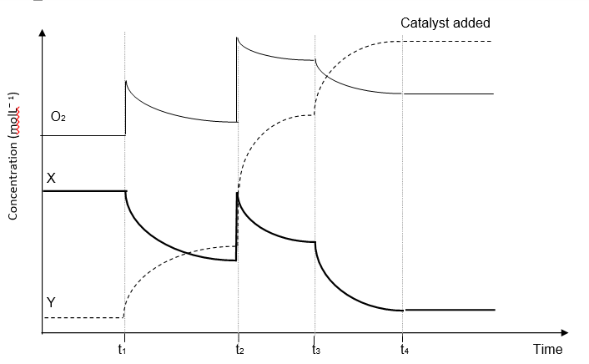

**Question 38** **continued**

(a) (i) Based on the change that took place at t1 it follows that:

X = **SO2** and Y = **SO3** **✓** (1 mark)

(ii) State what change is likely to have occurred at: (3 marks)

t1 **oxygen gas (O2) is added ✓**

t2 **the volume is decreased ✓**

***(don’t accept ‘pressure is increased’)***

t3 **the temperature is decreased** **✓**

(iii) At t4, a catalyst, vanadium pentoxide (V2O5), is added to the system.

Continue the graphs to represent the changes in concentration of the three

gases when a catalyst is added. (1 mark)

**Lines for each to show that [ ] of all species remains constant ✓**

(b) In the Contact Process, it is important to maximise both the yield of SO3 and the rate of reaction. Use your knowledge of equilibrium and rates to predict and explain the optimum conditions of temperature and pressure for production of SO3.

The equation for the production of SO3 is repeated below:

2 SO2(g) + O2(g) ⇄ 2 SO3(g) ΔH = −190 kJ mol−1

(7 marks)

**The rate of this chemical reaction will be increased by an increase in**

**temperature, and an increase in reactant concentration (pressure).**

**An increase in temperature increases rate since it increases the frequency**

**of collisions and the proportion of particles with sufficient kinetic energy for**

**bond breaking. ✓**

**An increase in pressure leads to increased frequency of collisions and hence**

**greater rate. ✓**

**The yield of sulfur trioxide will be increased by a low temperature and a**

**high pressure.**

**By LCP, a decrease in temperature will cause a shift in the direction of the**

**exothermic reaction – in this case, the forward reaction, so a shift to the right. ✓**

**An increase in pressure will increase the concentration of all species – both rates will increase but the forward rate more so (due to 3 : 2 ratio). ✓**

**The forward rate is, therefore, favoured until equilibrium is re-established,**

**increasing yield. ✓**

**Therefore, the optimum conditions are:**

**- a high pressure (which favours both rate and yield) ✓**

**- a moderate (compromise) temperature ✓**

**Question 38** **continued**

The full manufacture of sulfuric acid can be summarised in four main steps.

Step 1 Mining of “pyrite ore”, which contains, by mass, 73.00% FeS2.

Step 2 Roasting of the ore to convert the sulfur into sulfur dioxide

4 FeS2(s) + 11 O2(g) 🡒 2 Fe2O3(s) + 8 SO2(g)

Step 3 The oxidation of sulfur dioxide, which is only 68.00% efficient.

**(x4) 8** SO2(g) + **4** O2(g) ⇄ **8** SO3(g)

Step 4 Reaction of sulfur trioxide with water to form sulfuric acid

**(x8) 8** SO3(g) + **8** H2O(l) 🡒 **8** H2SO4(aq)

(c) Calculate the mass of sulfuric acid that can be produced from 1.000 tonne (1000 kg) of

“pyrite ore”. *(You may assume that all other reactions are 100% efficient)*

(7 marks)

**Assuming 100% efficiency:**

**m(FeS2) = 1 000 000 x 73/100 = 7.30 x 105 g ✓**

**n(FeS2) = 7.30 x 105 / 119.97 = 6.085 x 103 ✓**

**n(H2SO4) = 8/4 x n (FeS2) = 1.217 x 104 ✓✓✓**

***or n(SO2) = 8/4 x n(FeS2) = 1.217 x 104 ✓***

***n(SO3) = n(SO2) = 1.217 x 104 ✓***

***n(H2SO4) = (SO3) = 1.217 x 104 ✓***

**m(H2SO4) = 1.217 x 104 x 98.076 = 1.194 x 106 g ✓**

**Taking into account efficiency:**

**m(H2SO4) = 1.194 x 106 x 68/100 = 8.116 x 105 g = 812 kg ✓**

(d) The commercial concentrated sulfuric acid produced in the above process has a concentration of 18.00 mol L−1. Using the above quantities, what volume of this acid can be formed? Give your answer to four (4) significant figures.

(3 marks)

**n(H2SO4) = m/M = 8.116 x 105 / 98.076 = 8 275 mol ✓**

**V(H2SO4) = n/c = 8 275 / 18 = 459.7 L ✓**

**4 sig fig ✓**

***Follow through marks for incorrect answers from (c):***

***✓✓✓ 676.0 L if 1.19 tonnes***

***✓✓ 627.0 L if 1.19 tonnes***

**Question 39 (13 marks)**

This question concerns the three elements sodium, potassium and magnesium.

(a) Write equations to represent the first and seventh ionisation energies of sodium.

(2 marks)

1st I.E. **Na(g) 🡒 Na+(g) + e− ✓**

7th I.E. **Na6+(g) 🡒 Na7+(g) + e− ✓**

***Only a single penalty for writing energy rather than electron (e-)***

(b) Sketch a graph to show the trend in **all** the ionisation energies of sodium.

(3 marks)

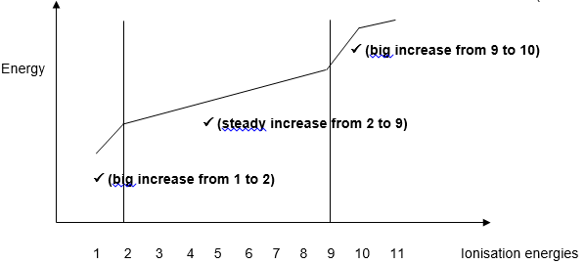

(c) Explain the shape of the above graph. (3 marks)

**Electron configuration of sodium is 2.8.1**

**IE 1 to 2: a big increase as the 2nd electron being removed from an**

**energy level closer to the nucleus, hence greater force of attraction. ✓**

**IE 2 to 9: there is a steady increase as the electrons are all in the same**

**shell but it gets progressively harder to remove an electron from an**

**increasingly positive charged ion. ✓**

**IE 9 to 10: again there is large jump in IE for the 10th electron as it is a**

**new electron shell closer to the nucleus, with less shielding. ✓**

**Question 39 continued**

(d) Which will have the higher first ionisation energy, sodium or potassium? Explain.

(2 marks)

**Sodium has the higher first IE ✓**

**K 2.8.8.1 Na is 2.8.1**

**Although potassium has more protons than sodium, ✓**

**its valence electron is located further from the nucleus ✓**

**(or increased nuclear charge is negated by the increase in shielding**

**from inner shell electrons)**

(e) Arrange the three elements (Na, K, Mg) in order of increasing electronegativity and explain your choice. (3 marks)

Order: *lowest* **K < Na < Mg** **✓** *highest*

Explanation

**Across the period:**

**Electronegativity increases due to the increase in nuclear charge with**

**electrons in same shell (similar shielding), hence Na < Mg ✓**

**Down a group:**

**Although nuclear charge increases, valence electrons are further from the**

**nucleus (there is a greater degree of shielding from inner shell electrons),**

**hence K < Na ✓**

**Question 40 (9 marks)**

(a) One tablet of Alka-Seltzer is completely dissolved in 270.0 mL of water, and all the bubbling has stopped. Calculate the final concentration in mol L-1 of

(i) sodium hydrogen carbonate (2 marks)

**m(NaHCO3) = 1700 mg = 1.700 g**

**n(NaHCO3) = m/M = 1.700/84.008 = 0.02024 mol**

**n(C6H8O7) = m/M = 0.300/192.124 = 0.001561 mol**

**n(NaHCO3)reacted = 3.n(C6H8O7) = 0.004684 mol**

**n(HCO3-)excess = n(NaHCO3)excess = 0.02024 – 0.004684 = 0.01556 mol ✓**

**[HCO3-] = n/V = 0.015556/0.270 = 0.0576 mol L-1 ✓**

(ii) aspirin (2 marks)

**m(C9H8O4) = 325 mg = 0.325 g**

**n(C9H8O4) = m/M = 0.325/180.154 = 0.001804 mol ✓**

**[C9H8O4] = n/V = 0.001804/0.270 = 0.00668 mol L-1 ✓**

(b) In the stomach, the normal concentration of hydrochloric acid is 0.160 mol L-1. The volume of the acid in the stomach can be assumed to be 0.650 L. A stressed student, studying for her WACE Chemistry examination, eats a whole packet of biscuits, causing her concentration of acid to rise to 0.200 mol L-1. Calculate how many Alka-Seltzer tablets she should take to reduce the level of acid back to normal. (5 marks)

3 NaHCO3(s) + C6H8O7(aq) → Na3C6H5O7(aq) + 3 H2O(l) + 3 CO2(g)

**n(H+)extra = Δc.V = (0.200 – 0.160) x 0.650 = 0.0260 mol ✓**

**H+(aq) + NaHCO3(s) → Na+(aq) + H2O(l) + CO2(g)**

**n(NaHCO3)required = n(H+) = 0.0260 mol ✓**

**n(HCO3-)required = (NaHCO3)required = n(H+) = 0.0260 mol ✓**

**In one tablet:**

**n(HCO3)excess = 0.01556 mol (from part (a)) ✓**

**∴ number of tablets = 0.0260 / 0.01556 = 1.67 ≈ 2 ✓**

**Question 41 (13 marks)**

(a) Determine the number of mole of chromium in the hydrated compound. (2 marks)

**n(Cr2(CO3)3) = m/M = 10.38/284.03 = 0.03655 mol ✓**

**n(Cr) = 2 x n(Cr2(CO3)3) = 0.0731 mol ✓**

(b) Determine the molar mass of the compound. (2 marks)

**n(compound) = n(Cr) = 0.0731 mol ✓**

**M(compound) = m/n = 36.5 / 0.0731 = 499 g mol-1 ✓**

(c) Calculate the values of ‘x’ and ‘y’ in the formula of the compound. (9 marks)

KCr(SO4)x.yH2O

**n(compound) = m/M = 4.70/499.4 = 0.009412 mol ✓**

**m(H2O) = 4.70 – 2.665 = 2.035 g ✓**

**n(H2O) = m/M = 2.035/18.016 = 0.1130 mol ✓**

**y = n(H2O)/n(compound) = 0.1130/0.009412 = 12 ✓**

**n(K) = n(compound) = 0.009412 mol**

**m(K) = n.M = 0.009412 x 39.10 = 0.3680 g ✓**

**n(Cr) = n(compound) = 0.009412 mol**

**m(Cr) = n.M = 0.009412 x 52.00 = 0.4894 g ✓**

**m(SO42-) = 2.665 – m(K) – m(Cr) = 1.808 g ✓**

***(or m(SO42-) = 4.70 – m(H2O) – m(K) – m(Cr) = 1.808 g)***

**n(SO42-) = m/M = 1.808/96.07 = 0.01882 mol ✓**

**x = n(SO42-)/n(compound)= 0.01882 / 0.009412 = 2 ✓**

***The values x and y needed to be determined by calculation, not based on a presumption of valences.***

**Question 42 (15 marks)**

An unknown alpha amino acid, X, containing the elements C, H, N and O, was subjected to analysis in order to determine its formula.

1st experiment 2.07 g of X was completely burned in excess oxygen and 3.07 g of carbon dioxide and 1.45 g of water were formed.

2nd experiment 1.68 g of X was reacted so as to convert all the nitrogen into nitrogen gas (N2). It was found that the gas formed occupied 211 mL, measured at STP.

3rd experiment 1.39 g of X was vapourised at 200oC and 105 kPa and was found to occupy a volume of 584 mL.

(a) Calculate the empirical formula of X. (12 marks)

**Samples with different masses, so use %**

|  |  |  |  |  |  |  |  |  |
| --- | --- | --- | --- | --- | --- | --- | --- | --- |
| **n(CO2) = 3.07 / 44.01**  **= 0.06976**  **n(C) = n(CO2)**  **= 0.06976 ✓**  **m(C) = 0.06976 x 12.01**  **= 0.838 g**  **% C = 0.838/ 2.07x 100**  **= 40.47%**  **✓** | | **n(H2O) = 1.47 / 18.016**  **= 0.08516**  **n(H) = 2 x n(H2O)**  **= 0.1630 ✓**  **m(H) = 0.1630 x 1.008**  **= 0.164 g**  **% H = 0.164 / 2.07 x 100**  **= 7.95%**  **✓** | | **(N2) = V / 22.71**  **= 0.211 / 22.71**  **= 0.00929**  **n(N) = 2 x n(N2)**  **= 0.01858 ✓**  **m(N) = 0.01858 x 14.01**  **= 0.260 ✓**  **% N = 0.264/1.68 x 100**  **= 15.48% ✓** | | **% O = 100 - %(C+H+O)**  **= 100 – (40.47 + 7.95 – 15.48)**  **= 36.10 % ✓** | | |
| **C** | **H** | | **N** | | **O** | |  |
| **40.47** | **7.95** | | **15.48** | | **36.10** | | **✓** |
| **12.01** | **1.008** | | **14.01** | | **16.00** | |  |
| **3.370** | **7.887** | | **1.105** | | **2.256** | | **✓** |
| **1.105** | | | | | | |  |
| **3.05** | **7.14** | | **1** | | **2.04** | | **✓** |

**EF = C3H7NO2 ✓**

(b) Calculate the molecular formula of X. (3 marks)

**n = PV / RT = (105 x 0.584) / (8.315 x 473.1) = 0.01559 mol ✓**

**M = m/n = 1.39 / 0.01559 = 89.16 g mol–1 ✓**

**EFM = 89.096**

**M ≈ EFM**

**∴ MF = EF = C3H7NO2  ✓**

**Question 43 (8 marks)**

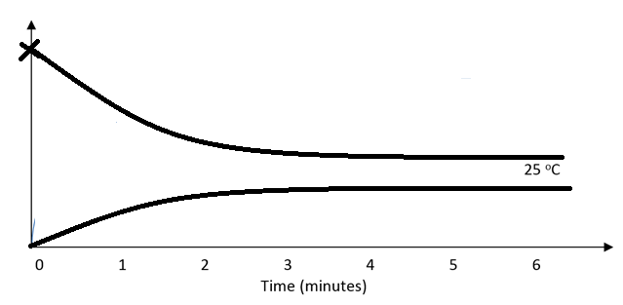

**Changes in concentration must reflect 2:1 ratio (from balanced equation) of NO2:N2O4**

(a) Which reaction was favoured as the temperature increased? Explain your choice.

(2 marks)

**The increased intensity of colour with increasing temperature**

**indicates that there is 🡑[NO2] and 🡓[N2O4] ✓**

**which means that the reverse reaction was favoured. ✓**

(b) Is the forward reaction endothermic or exothermic? Explain your choice. (2 marks)

**According to LCP, an increase in temperature causes a shift in equilibrium**

**in the direction of the endothermic reaction. ✓**

**∴ reverse reaction is endothermic and forward reaction is exothermic. ✓**

(c) On the graph on the previous page, sketch a curve that represents the concentration of

NO2(g) over the six minute period. (2 marks)

**🡓[NO2] twice 🡑[N2O4] ✓**

**[NO2] becomes constant at same time as [N2O4] - approx 3.5 mins ✓**

(d) At what temperature were reactions in the equilibrium mixture occurring most quickly? Explain why the rate of reaction was highest at this temperature. (2 marks)

**100⁰C ✓**

**At higher temperatures, collisions occur more frequently and a greater proportion of reactants have sufficient kinetic energy for bond breaking ✓**

**End of Examination**